

**Term Project**

Independent University, Bangladesh (IUB)

Department of CSE , Spring 2024

**CSE-307**

**Section : 03**

**Group : 21**

# Submitted to Submitted by

|  |  |
| --- | --- |
| **Sabrina Alam**  **Lecturer**  **School of Engineering, Technology and Sciences** | **Sumaiya Jannat**  **ID-1730469** |
| **Kaushik Dey Joy ID: 1821818** |
| **Jahid Hasan Milon**  **ID: 1930666** |
| **Abir Hossain Sangram**  **ID: 2022734** |

**Date :** *8th April, 2024*

**Contents**

1. Introduction: .............................................................6
2. History Leading to Project Request: ....................................... 6
3. Identify Problems, Solutions & Opportunities .....................7
   * Problem: ..................................................................7
   * Solutions: .................................................................7
   * Opportunities: ...........................................................8

Future enhancement of the project: ...................................... 8

1. Project goal and objectives ..........................................8

Goal: 8

Objectives: ...............................................................8

1. Product Description: ....................................................9

a.Product Summary ...........................................................9

b. Product Stakeholders: ....................................................9

1. System Context Diagram: ..........................................10
2. Hardware Detail: ..................................................11

* Rich Picture .......................................................11
* Components: .....................................................11

i) Hardware components: ................................11 ii) Software components: ........... 12

● Architecture: .......................................................12

1. Hardware architecture: .................................12
2. Software architecture: ............................12
3. Key Technical Features and Software: ...........................12
4. Information Gathering System: ....................................13
   * + Stories ..........................................................13
     + Interviewing ................................................14
     + Questionnaire ..................................................15
5. Major functionalities offered by the system: .................18

For Travelers: ................................................................18

For TourGuide:..............................................................18

For Admin: ...................................................................18

1. Use Case Diagram: ........................................19

12-13. Normal Scenarios and Alternative ................................. 19

1. Functional Requirements: .........................................24
2. Non-Functional Requirements: ..........................................24
3. Entity Relationship Diagram(ERD) .................................26
4. Logical Data Flow Diagram .................................................27
   1. Logical Data Flow Diagram for Whole Project............... 27
   2. Logical Data Flow Diagram for “Booking Hotel Room” ..28
   3. Logical Data Flow Diagram for “Booking Packages”.......... 28
   4. Logical Data Flow Diagram for “Translate” ..................29
5. Physical Data Flow diagram ........................................30
   1. Physical Data Flow Diagram for “Booking Hotel” ........32
   2. Physical Data Flow Diagram for “Packages” ................ 33
   3. Physical Data Flow Diagram for “Translate” ...................33

19.Activity diagrams .....................................................34

* 1. Activity Diagram for “Booking Hotel” ........................35
  2. Activity Diagram for “Package” ..................................36
  3. Activity Diagram for “Translate” ..............................37

1. Sequence diagrams ..................................................38
   1. Sequence Diagram for “Booking Hotel” ...................39
   2. Sequence Diagram for “Packages”........................... 41
   3. Sequence diagram for “Translate” .........................42
2. Communication diagrams ......................................43
   1. Communication Diagram for “Hotel Booked” .............. 44
   2. Communication Diagram for “Packages” ................... 45
   3. Communication Diagram for “Translate”...............46
3. Class diagram .................................................47
4. State-chart diagrams for whole system ..........................48
   1. State-chart diagram for “Hotel Booking” .................... 49
   2. State-chart diagram for “Packages” ......................... 50
   3. State-chart diagram for “Translation” ...............50
5. CRUD Matrix .....................................................52
6. Prototype the user interface .....................................53
   1. User Interface for Tourist ..............................53
   2. User Interface for Admin ..................................56

**Section 1:**

* + 1. **Introduction**:

Welcome to Tour maker, your gateway to seamless travel experiences! Our innovative software is designed to elevate your journeys across Bangladesh. With user-friendly navigation, real-time GPS tracking, and rich cultural insights, you'll explore historical landmarks, vibrant markets, and picturesque landscapes effortlessly. Whether you're an adventure seeker or a cultural enthusiast, Tour maker offers curated itineraries, language support, and safety tips, ensuring an informed and enjoyable trip. Uncover the hidden gems of Bangladesh while our software handles the logistics. Get ready to embark on unforgettable adventures with Tour maker

* + 1. **History Leading to Project Request**:

The inception of Tour maker software marks a pivotal moment in modern travel. Developed in response to the growing demand for immersive and organized exploration, this software emerged in 2010 as a collaborative effort between tech enthusiasts and seasoned tour guides. Fueled by a passion for Bangladesh's rich heritage and natural beauty, the software aimed to bridge the gap between travelers and authentic experiences. Through years of refinement, Tour maker evolved from a basic navigation tool

to a comprehensive travel companion. Its development involved local historians, cultural experts, and tech specialists, ensuring accuracy and depth in the provided information. By 2015, the software had integrated real-time GPS tracking, augmented reality features, and multilingual support, transforming the way people engaged with their surroundings.

Today Tour maker continues to empower travelers, offering a wealth of historical insights, off-the- beaten-path recommendations, and safety tips. As it evolves, it remains a testament to the fusion of technology and culture, enabling a new generation to uncover the wonders of Bangladesh effortlessly.

* + 1. **Identify Problems, Solutions & Opportunities**

* + - * **Problem:**

The Tour Maker software, while innovative, faces occasional connectivity hiccups in remote areas, limiting real-time GPS accuracy. Users have reported occasional discrepancies in historical information, highlighting the need for consistent content updates. Furthermore, the software lacks an integrated community feedback feature, which could enhance data accuracy and user engagement. These challenges, though minor, underline the software's potential for growth and continuous improvement in delivering seamless and reliable travel experiences across Bangladesh.

* + - * **Solutions:**

**Enhanced Offline Functionality:** To address connectivity issues in remote areas, Tour Maker software could incorporate an offline mode that allows users to download essential maps and content prior to their journey. This feature would ensure uninterrupted access to navigation and information even in areas with limited network coverage.

**Crowdsourced Content Validation:** Implementing a community feedback system within the software would empower users to contribute real-time updates and corrections to historical information. This collaborative approach could enhance data accuracy and enrich the overall experience, making the software a dynamic and reliable source of information.

**Regular Content Updates:** To maintain the software's accuracy, a dedicated team of historians, archaeologists, and cultural experts could periodically review and update the historical information database. This commitment to regular content updates would ensure that users receive the most current and accurate insights during their travels, fostering a deeper appreciation for Bangladesh's cultural heritage.

* + - * **Opportunities:** 
        1. **Global Expansion:** Tour Maker software could expand its reach to cover other countries, offering travelers a consistent and trusted companion for diverse destinations.
        2. **Partnerships:** Collaborations with local businesses, hotels, and attractions could provide users with exclusive deals and offers, enhancing their travel experience.
        3. **Educational Features:** Incorporating educational elements such as language lessons, historical quizzes, and cultural insights could turn the software into a comprehensive learning tool for travelers.

**Future enhancement of the project:**

Future enhancements of the tour guide software project may include AI-driven personalized

itineraries, real-time translation for multilingual support, and integration with wearable devices for seamless hands-free navigation.

* + - * 1. **Project goal and objectives**

**Goal:**

The primary goal of Tour Maker software is to provide travelers with an immersive and insightful journey through Bangladesh, offering accurate historical information, seamless navigation, and local insights. By fostering a deeper understanding of the country's cultural heritage and natural beauty, the software aims to enhance travel experiences while promoting sustainable and responsible tourism practices.

**Objectives:**

* + - 1. **Accuracy:** Ensure the software offers up-to-date and accurate historical, cultural, and geographical information about Bangladesh's landmarks and attractions.
      2. **User-Friendly Interface:** Create an intuitive and user-friendly interface for easy navigation and engagement, catering to both tech-savvy travelers and those less familiar with technology.
      3. **Localization:** Provide content in multiple languages and dialects to cater to a diverse range of travelers and ensure inclusivity.
      4. **Offline Functionality:** Develop an offline mode to enable users to access essential information and maps even in areas with limited connectivity.
      5. **Community Engagement:** Implement a feedback system allowing users to contribute corrections and updates, enhancing the software's reliability and depth of information.
      6. **Innovation:** Continuously integrate new technologies such as augmented reality, AI-driven recommendations, and wearables for a cutting-edge travel experience.
      7. **Partnerships:** Establish collaborations with local businesses, attractions, and tour guides to offer users exclusive deals and insider experiences.

* + - 1. **Education:** Incorporate educational elements to enhance users' knowledge about Bangladesh's history, language, and culture during their travels.

**Section 2:**

* + 1. **Product Description:**

* + 1. **Product Summary**

Tour Maker software is a comprehensive travel companion designed to elevate journeys across

Bangladesh. This innovative solution combines accurate historical insights, real-time GPS navigation, and local expertise to provide travelers with immersive and insightful experiences. With a user-friendly interface, the software caters to both tech-savvy individuals and those less familiar with technology, ensuring easy access for all.Tour Maker offers multilingual support, making it accessible to a diverse range of travelers. Its offline functionality ensures uninterrupted access to essential information and maps, even in areas with limited connectivity. The software's community engagement feature allows users to contribute corrections and updates, enhancing the reliability and depth of information available.

By integrating cutting-edge technologies such as augmented reality and AI-driven recommendations, Tour Maker remains at the forefront of travel innovation. It not only enhances the travel experience but also promotes responsible tourism practices by fostering a deeper understanding of Bangladesh's cultural heritage and natural wonders.

* + 1. **Product Stakeholders:**

The stakeholders who are involved in my product are mentioned below:

Travelers

Tour Guides

Admin

* + 1. **System Context Diagram:**

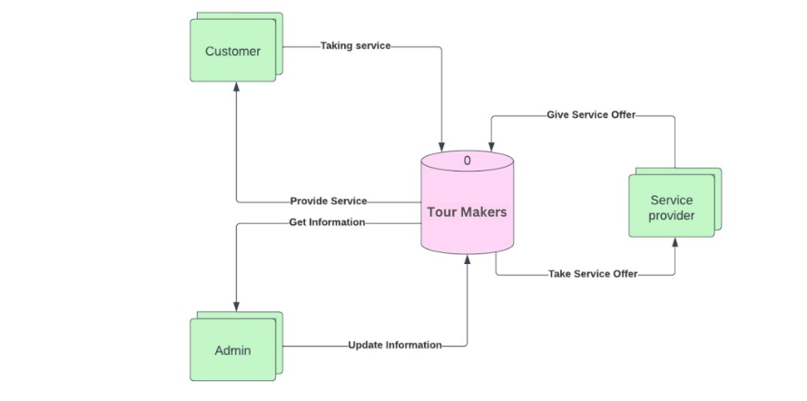

* + 1. **Hardware Detail:**

* + - * **Rich Picture**

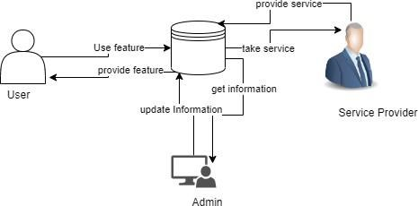

* + - * **Components:** 
        1. **Hardware components:**

The hardware components that would be required are given below:

Smartphone

Laptop or desktop computer

Active Internet connection

* + - * 1. **Software components:**

The software components that would be required are given below:

XAMPP for Windows v8.1.2 with Control Panel v3.3.0 and PHP v8.1.2

Android Studio

**● Architecture:**

**i) Hardware architecture:**

The required hardware architecture is mentioned below:

A laptop or desktop computer with at least 8 GB RAM and 128 GB SSD and Intel Core i5 processors

A smartphone with enough memory and processing power

A stable and reliable Internet connection with at least speed of 15 MBPS

**ii) Software architecture:**

The required software architecture is mentioned below:

Windows 11 v21H2 (at least Windows 10)

Android version 8.0 (Oreo) or above with Google Play Services

* + 1. **Key Technical Features and Software:**

The technical features of the software are mentioned below:

▪ **Real-time GPS Navigation:** Accurate GPS tracking allows travelers to navigate through unfamiliar areas confidently, ensuring they reach their destinations efficiently.

▪ **Offline Mode:** The offline functionality ensures that users can access maps and essential information even without an internet connection, vital for areas with limited connectivity.

▪ **Community Feedback:** By allowing users to contribute corrections and updates, the software benefits from collective knowledge and ensures information accuracy.

▪ **Partnerships:** Collaborations with local businesses, attractions, and tour guides provide users with exclusive offers and unique experiences.

▪ **Responsive Design:** The software's user interface is designed to adapt seamlessly across various devices, ensuring a consistent experience on smartphones, tablets, and desktops.

▪ **AI-driven Recommendations:** The software's AI can analyze user preferences and behaviors to offer personalized recommendations for attractions, activities, and routes.

**Section 3:**

1. **Information Gathering System:**

The Information Gathering System of Tour Maker software employs a network of historians, cultural experts, and local sources to curate accurate historical data, cultural insights, and geographical details. Regular updates and community feedback contribute to maintaining the reliability and relevance of information for travelers exploring Bangladesh.

❖ **Stories**

**Story 1:**

In the heart of Dhaka, Tour Guide BD's information gathering system came to life. A team of cultural experts, historians, and tech enthusiasts gathered at a bustling bazaar, documenting the vibrant tapestry of Bangladesh's culture. They interviewed local artisans, capturing their stories and crafts to be shared through the software. Immersed in the colorful chaos, they collected historical anecdotes from elders, enriching the app with authentic tales. Back at their studio, these narratives were meticulously organized, forming a virtual treasure trove of cultural insights that travelers would soon explore, bridging the gap between past and present.

**Findings from the story:**

* + - * Enthusiasts worldwide could study artifacts without physical presence.

* + - * Reduced handling preserved fragile artifacts.

* + - * Users engaged with history through immersive experiences.

**Story 2:**

High in the hills of Chittagong, the information gathering system of Tour Maker faced its toughest test. A team of explorers ventured into an area with minimal connectivity, aiming to map hidden trails and uncover offbeat attractions. Armed with satellite devices, they hiked through dense forests, capturing GPS coordinates and photographs of unique flora and fauna. At night, under the stars, they gathered around a campfire to interview local villagers, recording folklore and legends. Despite challenges, their dedication resulted in a database of remote gems, demonstrating the software's commitment to providing comprehensive travel experiences.

**Findings from the story:**

* + - * Visitors supported conservation efforts through sustainable travel.

* + - * Trails directed visitors away from vulnerable areas.

* + - * Users learned about biodiversity and sustainability while trekking.

❖ **Interviewing**

Interviews are one-on-one or small-group talks with stakeholders to learn about their needs, requirements, and expectations. Interviews, which can be organized or unstructured depending on the demands of the system, are frequently used to acquire comprehensive information from subject matter experts or end-users.

Tour Maker software offers an easy-to-use interface, intuitive navigation, and robust features, making it an ideal solution for both tour operators and tourists. Its interactive map, multilingual support, and seamless booking system ensure a delightful experience for all stakeholders involved in the tourism industry.

**Selected interviewee:** Travelers **Questions for Travelers:**

* + - 1. What motivated you to visit Bangladesh, and what specific aspects of its culture or attractions are you excited to explore?

* + - 1. Have you visited any historical landmarks or cultural sites in Bangladesh so far?

* + - 1. Are you interested in off-the-beaten-path destinations or well-known tourist attractions?

* + - 1. How comfortable are you with technology?

* + - 1. What languages do you speak or understand?
      2. Are you interested in learning about local traditions, languages, or traditional crafts during your journey?

* + - 1. Do you prefer guided tours or independent exploration?

* + - 1. How do you usually plan your trips?
      2. Are you conscious of sustainable and responsible travel practices?
      3. Are you open to contributing your experiences and insights to the Tour Maker community?

**Selected interviewee:** Tour Guides **Questions for Tour Guides:**

* + - 1. How familiar are you with the cultural history and landmarks of Bangladesh?

* + - 1. Can you provide an example of a challenging situation you've encountered while guiding tourists?

* + - 1. How do you approach delivering historical and cultural information in an engaging and memorable way?

* + - 1. Can you provide examples of your experience as a tour guide?

* + - 1. How would you handle unexpected changes or disruptions during a tour?

* + - 1. How comfortable are you with using technology?

* + - 1. What languages are you proficient in?

* + - 1. How would you incorporate personal anecdotes or local stories to make the tour more engaging?

* + - 1. Have you ever used augmented reality or GPS navigation systems for tours?

* + - 1. Can you share your approach to maintaining a positive and engaging atmosphere throughout a tour?

❖ **Questionnaire**

The questionnaires for Tour Maker aim to assess candidates' expertise in cultural insights, communication, and technology. Questions cover tour experience, handling unexpected situations, language proficiency, tech familiarity, and methods to engage travelers. Candidates' ability to ensure accurate information, promote responsible tourism, and adapt tours to diverse groups is also evaluated. The questionnaires help identify candidates who align with Tour Guide BD's goals of delivering immersive and educational travel experiences.

**Selected stakeholder:** Travelers

**(Personal Information)**

**Read questions 1-7 and circle the appropriate answer:**

* + - 1. Name

* + - 1. Select your gender:

* + - * Male

* + - * Female

* + - * Other

3. Age

* + - * Under 18

* + - * 18 to 24

* + - * 25 to 34

* + - * 35 to 44

* + - * 45 to 54

* + - * Over 55

* + - * Prefer not to answer

4. How often do you travel within Bangladesh?

* + - * + Rarely

* + - * + Occasionally

* + - * + Frequently

5. How do you usually plan your trips? (Select all that apply)?

* + - * Through travel agencies

* + - * Recommendations from friends/family

* + - * Spontaneous decisions

6. Which regions or cities in Bangladesh are you interested in exploring?

* + - * + Dhaka

* + - * + Cox's Bazar

* + - * + Sundarbans

* + - * + Chittagong

* + - * + Rajshahi

7. What types of tours are you most interested in?

* + - * + Historical and Cultural Tours

* + - * + Nature and Wildlife Tours

* + - * + Adventure and Trekking Tours

* + - * + Beach and Coastal Tours

8. Are you planning to travel alone or with a group?

* + - * + Alone

* + - * + Group

9. What features of the app do you use the most?

* + - * + Tourist attractions information

* + - * + Maps and navigation

* + - * + Local events

1. **Major functionalities offered by the system:**

**For Travelers:**

* + - **Real-time Navigation:** Accurate GPS navigation guides travelers seamlessly to their desired destinations, ensuring they don't miss any attractions.
    - **Offline Access:** Essential information, maps, and guides can be accessed offline, beneficial in areas with limited connectivity.
    - **Interactive Maps:** Interactive maps help users explore attractions, dining options, accommodations, and more.
    - **Safety Tips:** Safety guidelines and tips provide travelers with essential information for a secure journey.
    - **Community Feedback:** Travelers can contribute corrections and updates, enhancing the accuracy of information.
    - **Language Learning:** Language lessons enable travelers to communicate with locals and immerse themselves in the culture.

**For Tour Guide:**

* + - **Accurate Information:** Provide reliable historical, cultural, and geographical information about landmarks and attractions.
    - **Partnership Offers:** Collaborate with local businesses for exclusive deals, enhancing travelers' experiences.
    - **Sustainable Tourism Tips:** Provide guidance on responsible travel practices, respecting local culture and environment.

**For Admin:**

* + - **Booking Management:** Allow hotel managers to update room availability, rates, and manage reservations efficiently.
    - **Guest Services:** Enable communication with guests for special requests, room preferences, and inquiries.
    - **Payment Processing:** Facilitate secure online payments and invoicing for reservations and services.
    - **Emergency Assistance:** Provide mechanisms for drivers to report emergencies or accidents for immediate assistance.
    - **Feedback Collection:** Gather traveler feedback on transportation experiences to continuously improve services.

1. **Use Case Diagram:**

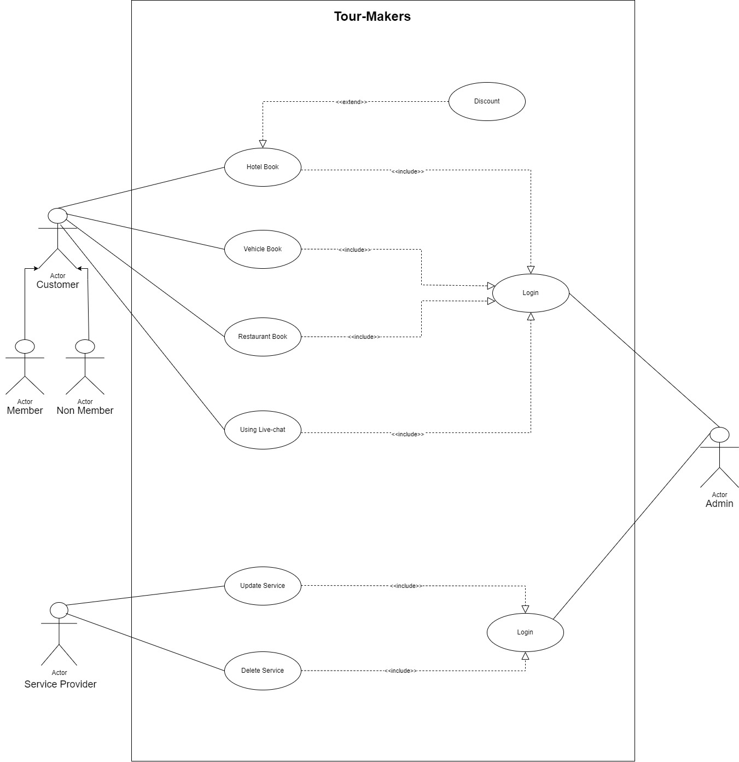

**12-13. Normal Scenarios and Alternative Scenarios:**

**Use case Table 1:**

|  |  |
| --- | --- |
| **User Case name**: Communicate with  Tour maker | Unique Id: CTG101 |
| **Area:** Tourist Dashboard |  |
| **Actor(s):** Tourist, Tour Guide | |
| **Stakeholder(s):** Tourist (Customer), Tour Guide | |
| **Description:** Tourists can communicate directly with their assigned tour guides through the tour maker software to seek information, ask questions, and receive updates before and during the tour. | |
| **Triggering Event:** Tourist initiates a communication request with the assigned tour guide through the tour maker software's messaging feature. | |
| **Trigger type:** External | |
| **Step Performed(Main Path)** | **Information For Steps** |
| 1. The tourist logs into the tour guide software. | User ID, Password |
| 2. In the tour details section, there is a dedicated "Communicate with Guide" option. | Customer dashboard |
| 3. The tourist clicks on the option to initiate communication. |  |
| 4. A messaging interface opens up, allowing the tourist to type their message and send it to the assigned tour guide. | All required information must be filled up |
| 5. The software confirms the successful delivery of the message to the tour guide. |  |

|  |  |
| --- | --- |
| 6. The tour guide, who is also using the tour guide software, receives a notification of the new message. | Get notified |
| 7. The tour guide views the message and responds with appropriate information or assistance. | Feedback |
| 8. The tourist receives the tour guide’s response in the messaging |  |

|  |
| --- |
| **Alternative Scenario:**  · If the assigned tour guide is unavailable or does not respond within a reasonable time, the tour maker software can escalate the communication to the tour operator's customer support team.  · In case of technical issues or network problems, the software may encounter difficulty in delivering the message to the tour guide.  · There could be instances where the originally assigned tour guide becomes unavailable due to unforeseen circumstances. |
| **Preconditions:**   * The tour maker software is accessible and functioning correctly. * The tourist has booked a tour and is registered/logged into the tour maker software. * The tour operator has assigned a tour guide to the tourist's booked tour. |
| **Post-conditions:**   * The tourist's message is successfully sent to the assigned tour guide. * The tour guide receives the message through the tour maker software or a connected communication channel. * The conversation history between the tourist and the tour guide is logged and can be reviewed later if needed. |
| **Assumptions:**  · Tourists are registered users of the tour maker software and have valid booking details.  · Tour guides are assigned to specific tours and have access to the communication feature in the software.  · The tour maker software has a secure messaging system to ensure privacy |
| **Success Guarantee:** Tourists can easily and securely communicate with their assigned tour guides before and during the tour. The messages are delivered promptly, and both tourists and guides can receive and send messages without any technical hindrances. |
| **Minimum Guarantee:** The tour maker software ensures that all communication sent by tourists reaches their assigned tour guides. At the minimum, tourists can send messages to their guides, even if the response time is not instantaneous. |
| **Requirements Met:**  The communication feature in the software allows tourists to select the specific tour and guide they want to contact. |

|  |
| --- |
| **Outstanding Issues:**  • While the software ensures basic communication between tourists and guides, it may lack advanced features like real-time chat, video calling, or translation support for international tourists. |
| **Priority:** High |
| **Risk:** Low |

**Use case Table 2:**

|  |  |
| --- | --- |
| **User Case name**: Tour Booking and  Reservation | Unique Id: TBR102 |
| **Area:** Tourist Dashboard | |
| **Actor(s):** Tourist (Customer) | |
| **Stakeholder(s):** Tourist (Customer),Tour Guide | |
| **Description:** This use case describes the process of a tourist booking and reserving a guided tour in Bangladesh through the tour maker software | |
| **Triggering Event:** A tourist expresses interest in booking a guided tour through the tour maker software. | |
| **Trigger type:** External trigger (initiated by the tourist). | |
| **Step Performed(Main Path)** | **Information For Steps** |
| 1. The tourist opens the tour maker software or website and logs in with their account credentials. | User ID, Password |
| 2. The software presents a list of available tours with their descriptions, dates, prices, and | Tourist dashboard, Tour descriptions, dates, and prices. |
| 3. The tourist selects a preferred tour from the list. | Selected tour choice. |
| 4. The software displays the detailed itinerary, including the places to visit, activities, and duration | Desired tour date and time. |
| 5. The tourist checks the availability of slots for the chosen tour and selects the desired date and time. |  |

|  |
| --- |
| **Alternative Scenario:**   * Get Tour Updates and Reminders * Communicate with Tour Guides * Submit Feedback and Reviews * Book a Tour |
| **Preconditions:**   * The tour maker software is up and running. * The tourist has access to the tour maker software and is registered/logged in. |
| **Post-conditions:**   * The tourist's booking is confirmed, and the tour slot is reserved. * The tourist receives the booking confirmation with all relevant details. |
| **Assumptions:**   * The tour maker software is fully functional and accessible to tourists. * The account information provided by the account manager is accurate. |
| **Success Guarantee:** The success guarantee for the "Tour Booking and Reservation" scenario is that tourists can successfully browse available tours, select their preferred tour, check for available slots, and complete the booking process without any technical |
| **Minimum Guarantee:**  · he minimum guarantee is that tourists can view the list of available tours and see basic information about each tour, even if they do not proceed with the booking.  · The software should also inform tourists if a selected tour is fully booked or |
| **Requirements Met:**  Tourists can view available tours and itineraries with detailed descriptions. |
| **Outstanding Issues:**   * Occasionally, the tour availability data might not be synchronized in real-time, leading to discrepancies between displayed availability and actual slots. * Payment processing might fail due to issues with the payment gateway or connectivity problems. * The software may lack support for multiple languages, limiting accessibility for non- English speaking tourists. * Some tourists may encounter difficulties in using the software due to an unfamiliar user interface. |
| **Priority:** High |
| **Risk:** High |

1. **Functional Requirements:** 
   * 1. Users can create accounts and profiles with personal information and preferences. Profiles can be customized to save favorite destinations, language preferences, and travel history.
     2. Real-time GPS navigation guides users to landmarks, attractions, and accommodations. Turnby- turn directions with estimated travel times are provided for each destination.
     3. Content is available in multiple languages to cater to a diverse range of travelers. Users can easily switch between languages for all software features.
     4. Detailed historical information is provided for landmarks and attractions. Users can access narratives, dates, and significance of each site.
     5. Users can download maps, content, and navigation data for offline use in areas with limited connectivity. Offline mode ensures seamless access to essential information during travel.

* + 1. Users receive safety information and guidelines for each destination. Tips on local customs, emergency numbers, and precautions are provided.

1. **Non-Functional Requirements:**

The non-functional requirements of the system are as follows:

**Reliability:**

* + - * **System Uptime:** The Tour Makersoftware should maintain at least 99% uptime, ensuring users can access information and navigation services consistently.

* + - * **Data Accuracy:** Information about historical sites, cultural insights, and maps must be accurate and up-to-date to provide reliable guidance to travelers.

**Performance:**

* + - * **Response Time:** The software should provide quick responses to user interactions, with an average response time of under 2 seconds for navigation and information retrieval.

* + - * **Scalability:** The system should handle increased user traffic during peak travel seasons without significant performance degradation..

**Maintainability:**

* + - * **Modular Design:** The software should be built with a modular architecture, allowing for easy updates and additions to features.

* + - * **Code Documentation:** Clear and comprehensive documentation for the codebase should be maintained to facilitate future maintenance and development.

**Efficiency:**

The system must be able to accommodate at least 10,000 individuals at the same time while also consuming minimal resources such as memory, CPU, and disk space.

**Security:**

* + - * **Data Encryption:** User data, payment information, and personal details should be encrypted to ensure their confidentiality during transmission and storage.

* + - * **Authentication and Authorization:** Implement robust user authentication and authorization mechanisms to prevent unauthorized access to the software's functionalities.

**Section 4:**

1. **Entity Relationship Diagram (ERD)**

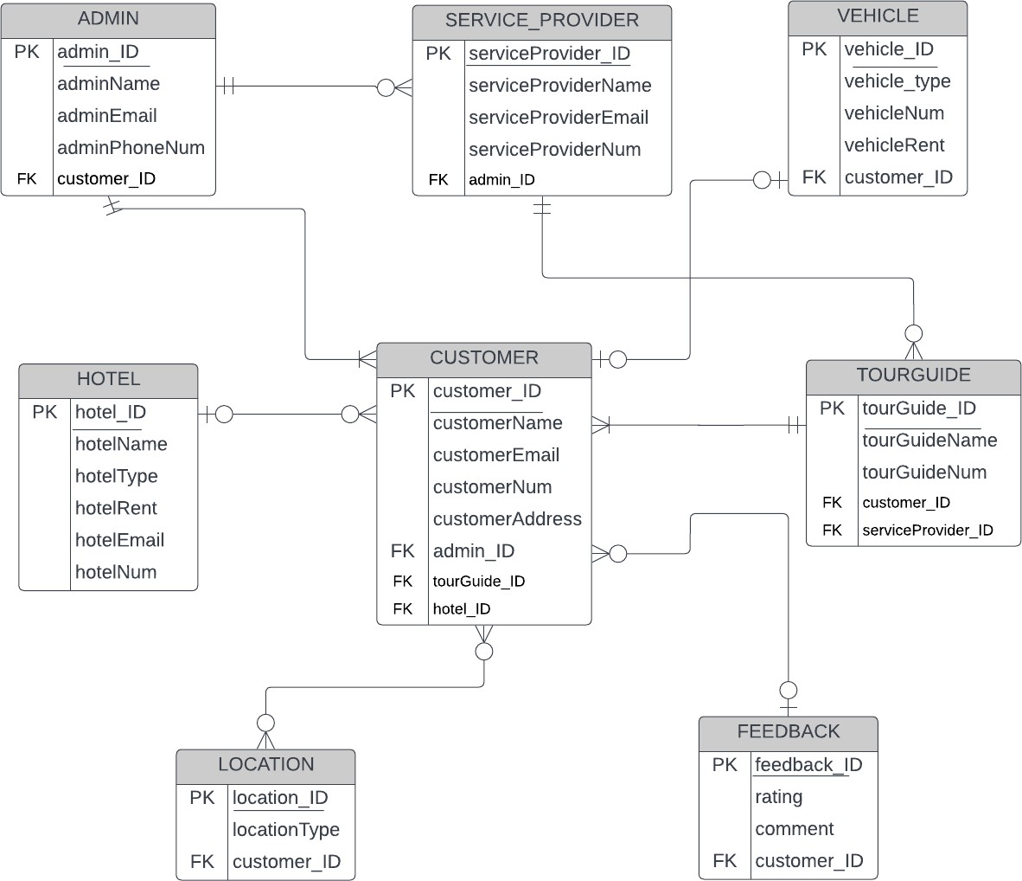

1. **Logical Data Flow Diagram**

* 1. **Logical Data Flow Diagram for Whole Project**

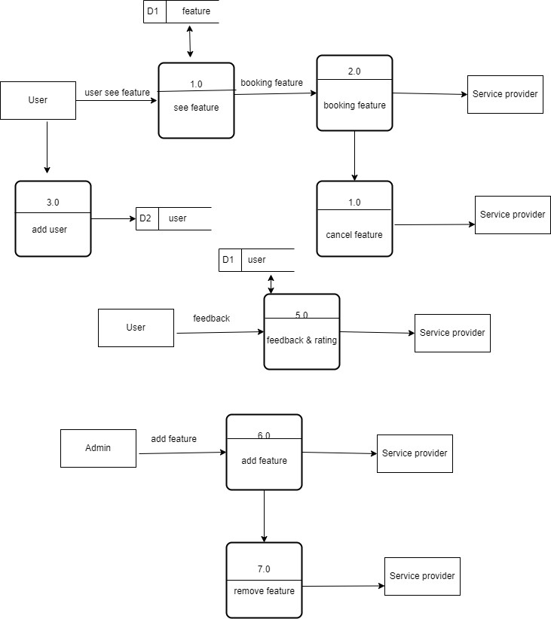

* 1. **Logical Data Flow Diagram for “Booking Hotel Room”**

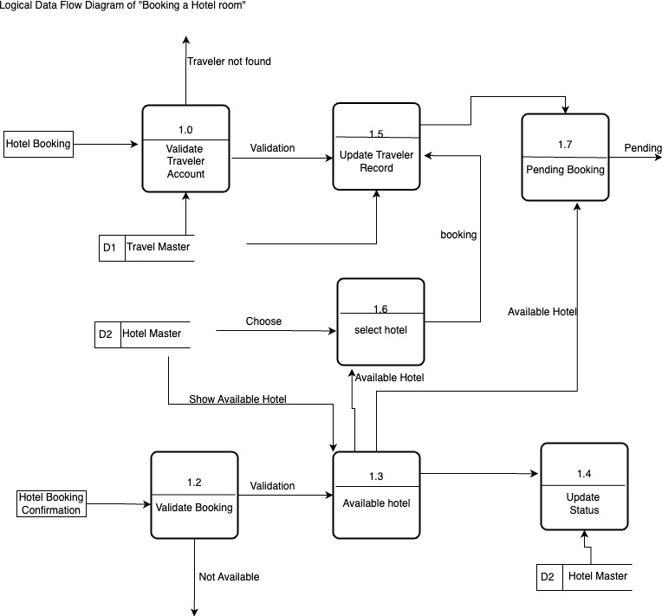

## 17.3. Logical Data Flow Diagram for “Booking Packages”

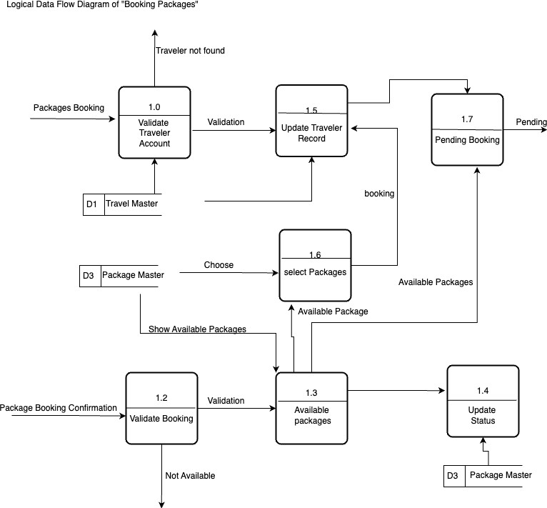

**17.4. Logical Data Flow Diagram for “Translate”**

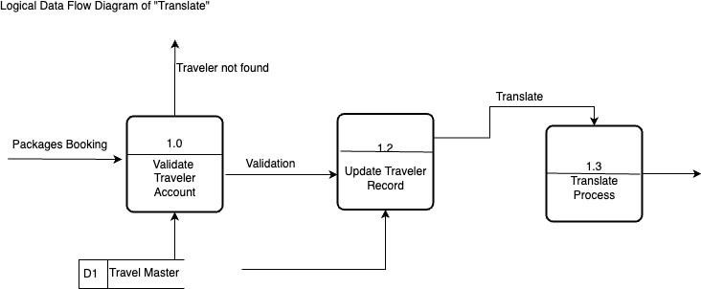

1. **Physical Data Flow diagram**

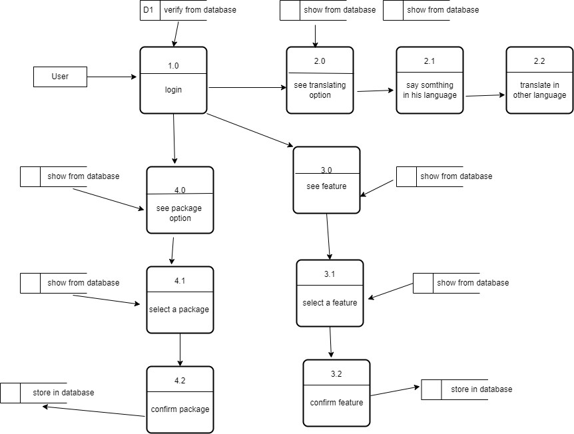

* 1. **Physical Data Flow Diagram for “Booking Hotel”**

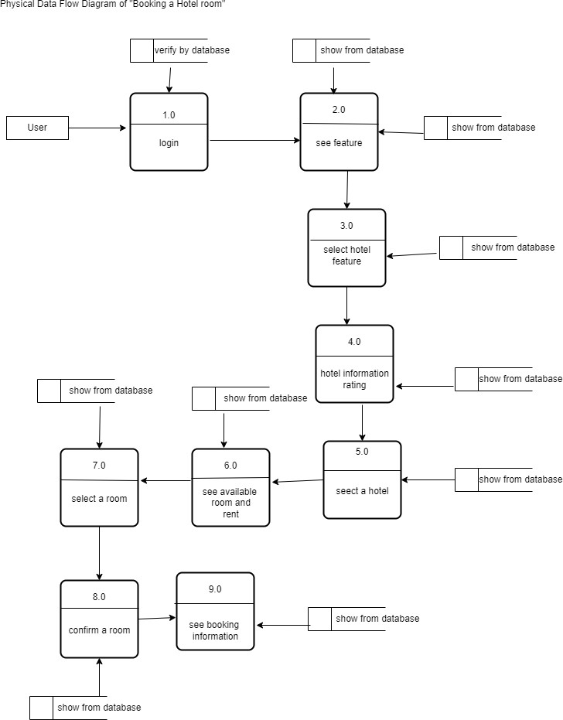

* 1. **Physical Data Flow Diagram for “Packages”**

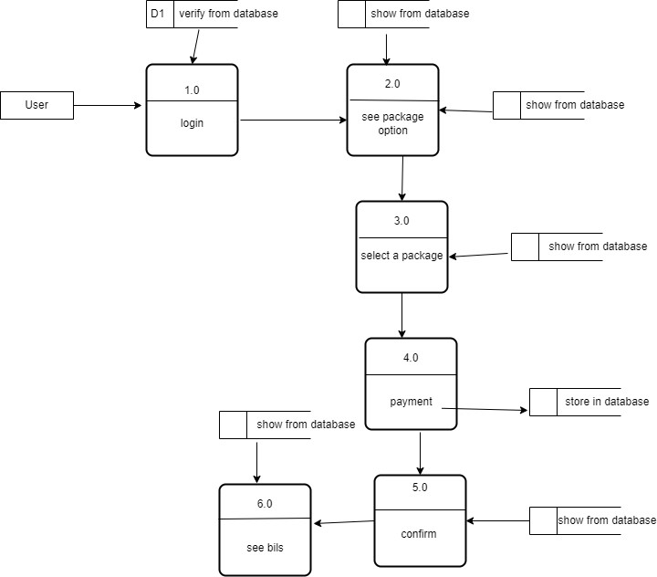

**18.1. Physical Data Flow Diagram for “Translate”**

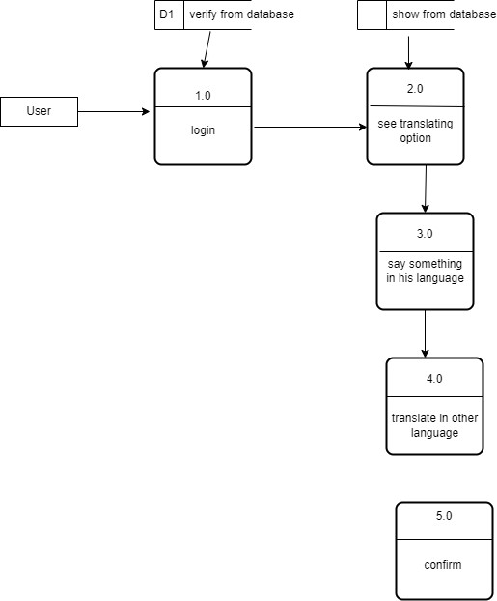

**14.Activity diagrams**

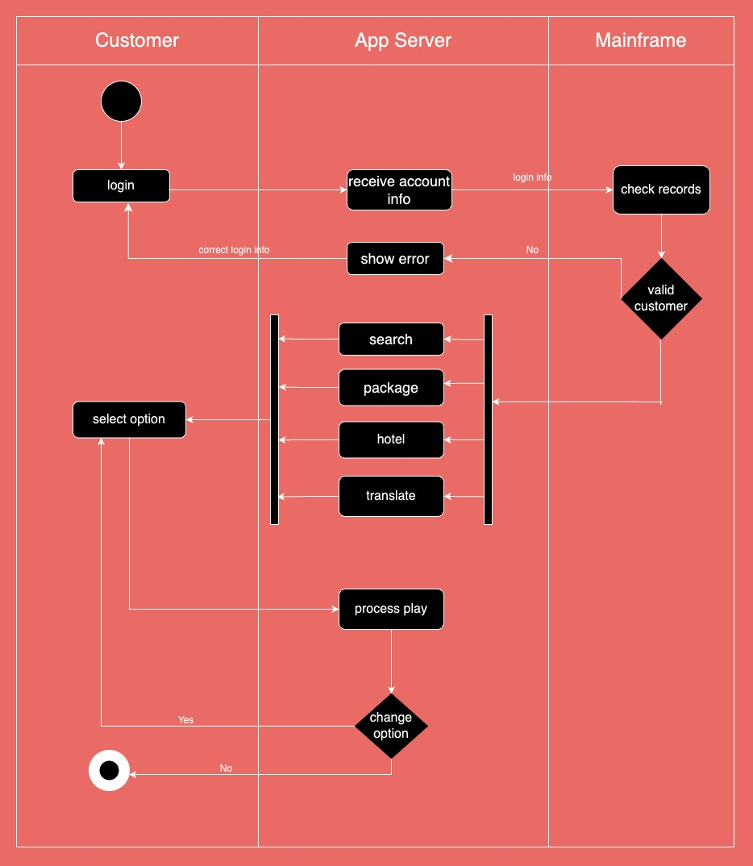

**19.1. Activity Diagram for “Booking Hotel”**

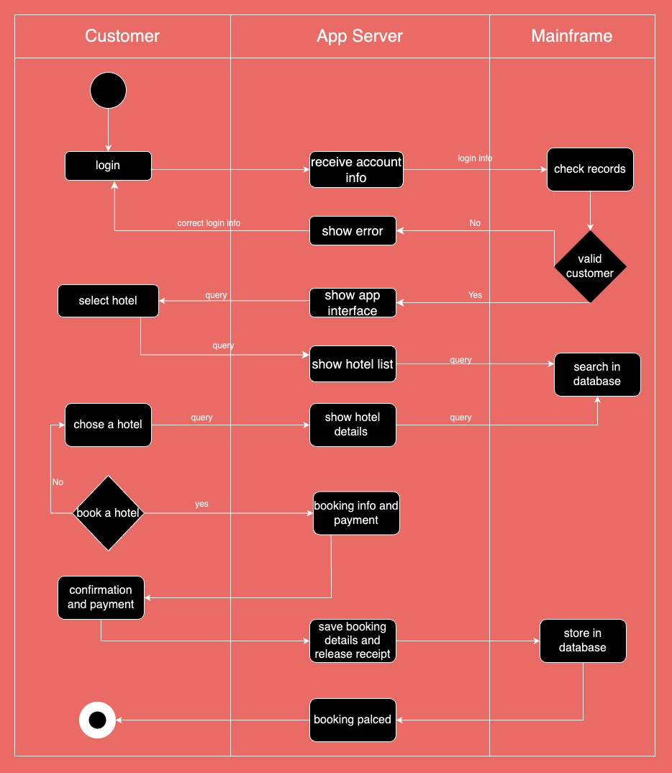

* 1. **Activity Diagram for “Package”**

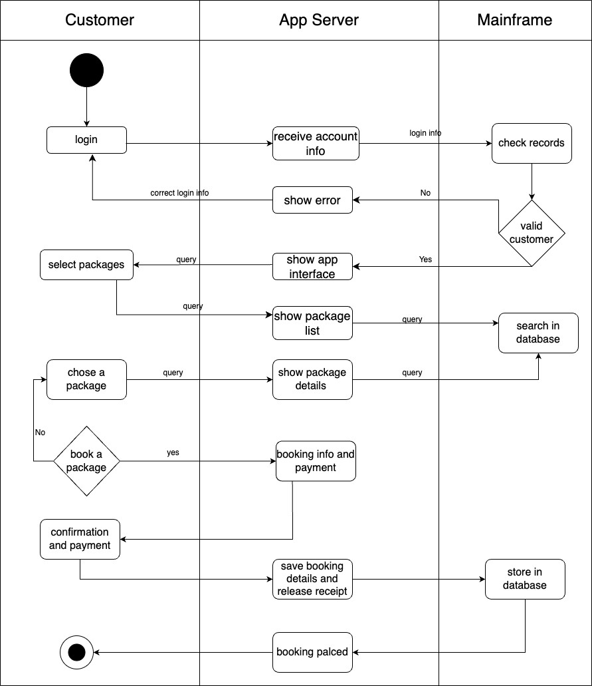

* 1. **Activity Diagram for “Translate”**

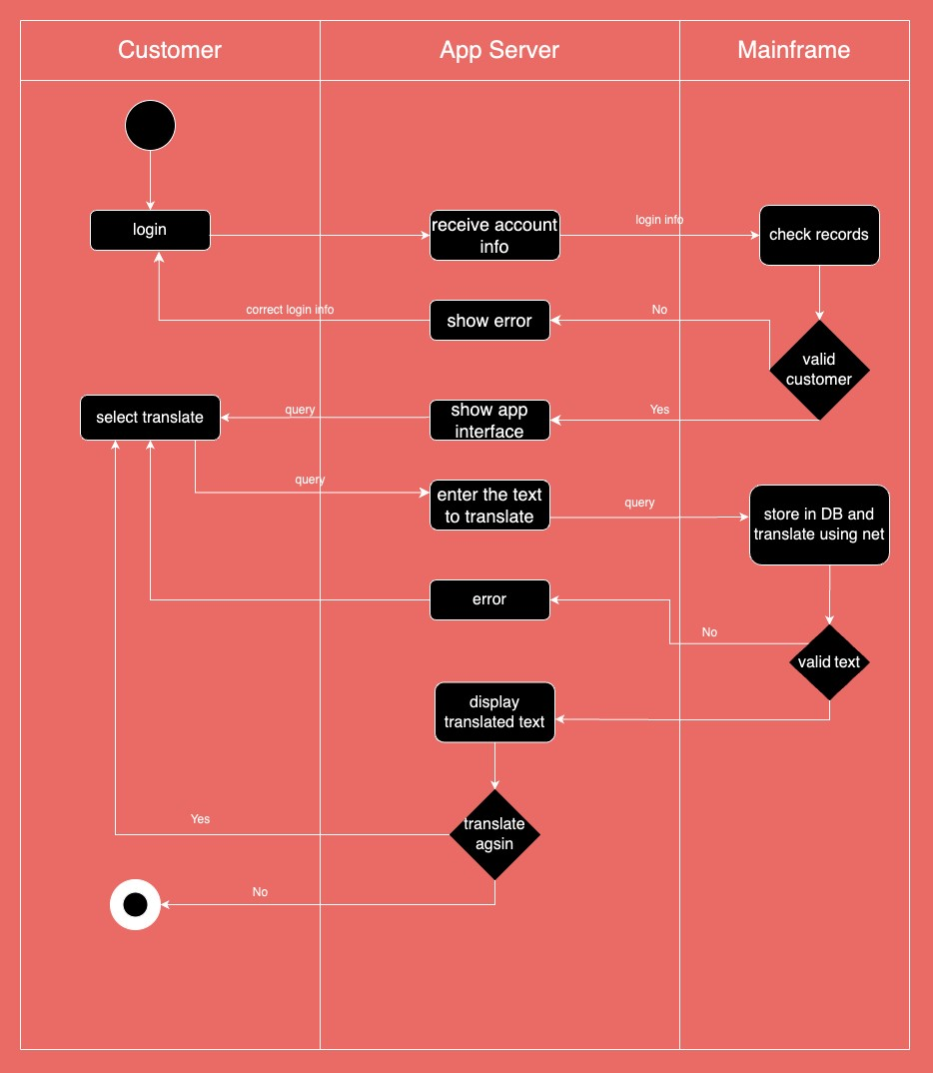

1. **Sequence diagrams**

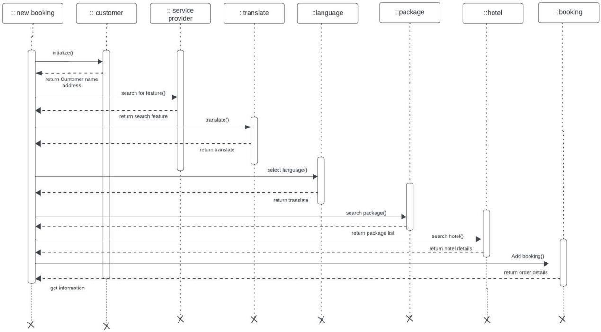

* 1. **Sequence Diagram for “Booking Hotel”**

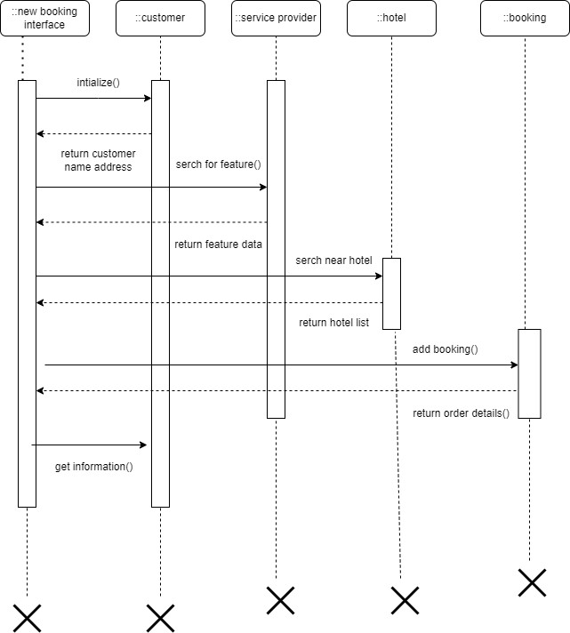

* 1. **Sequence Diagram for “Packages”**

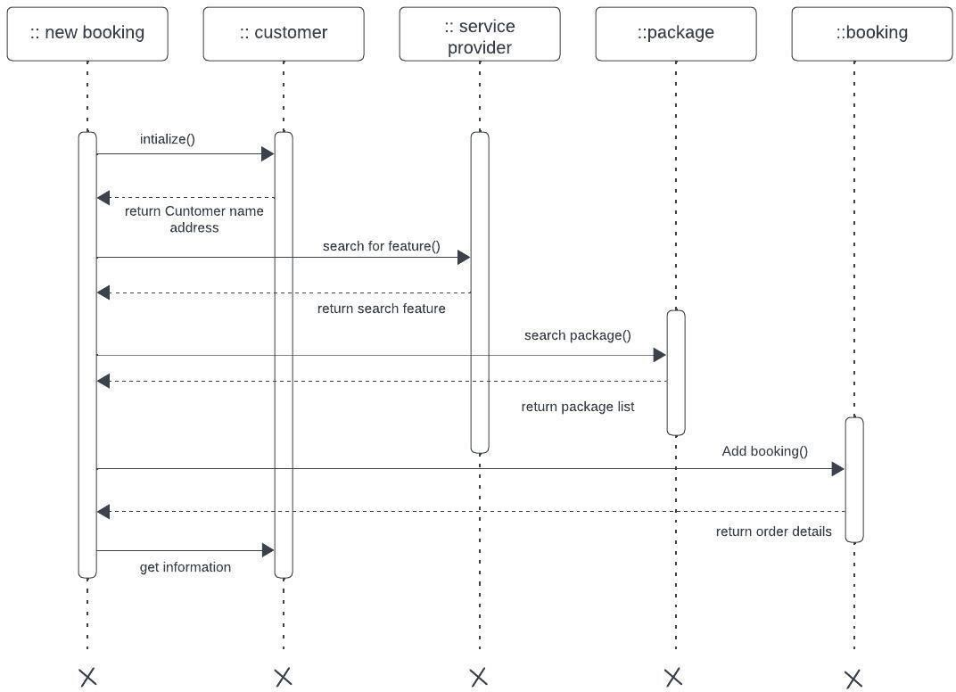

* 1. **Sequence diagram for “Translate”**

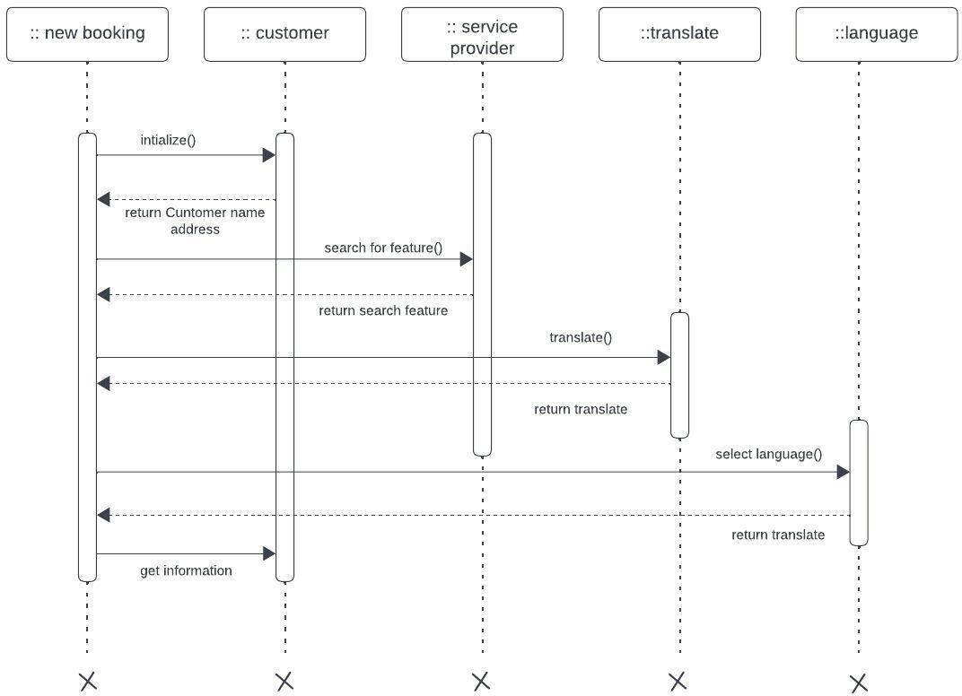

1. **Communication diagrams**

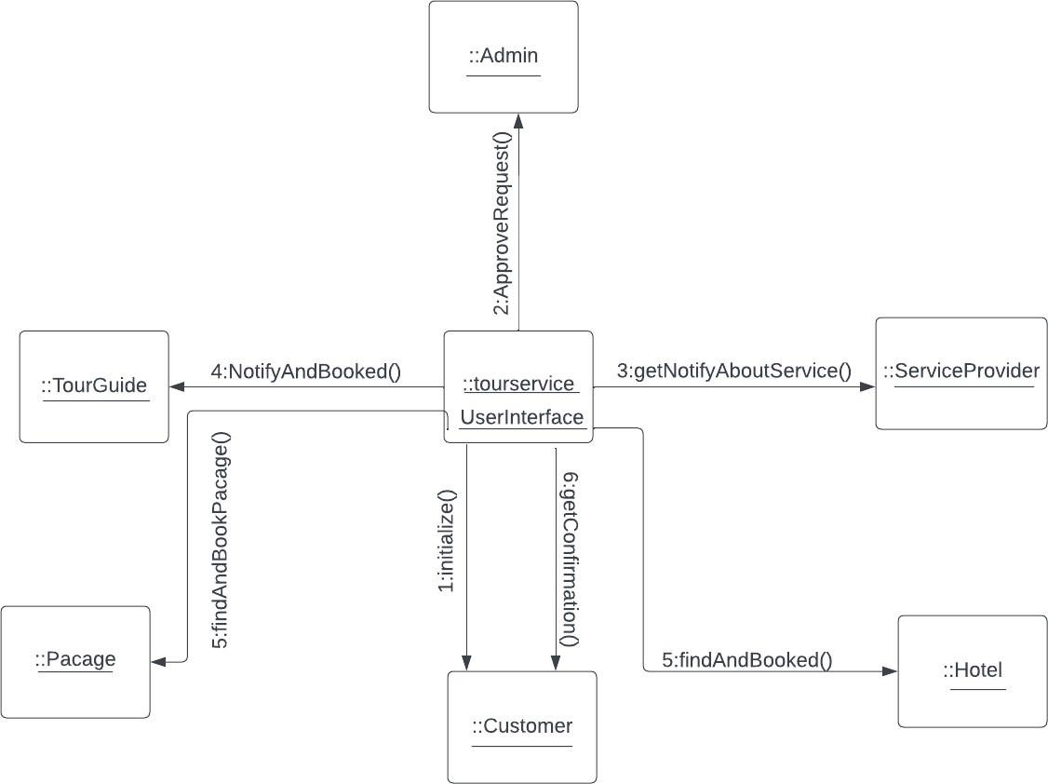

* 1. **Communication Diagram for “Hotel Booked”**

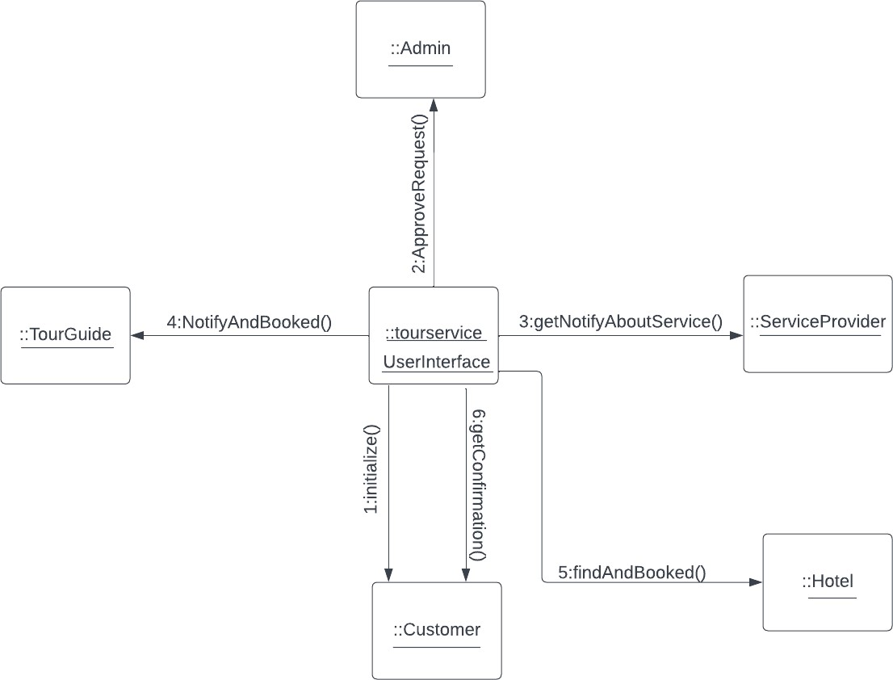

* 1. **Communication Diagram for “Packages”**

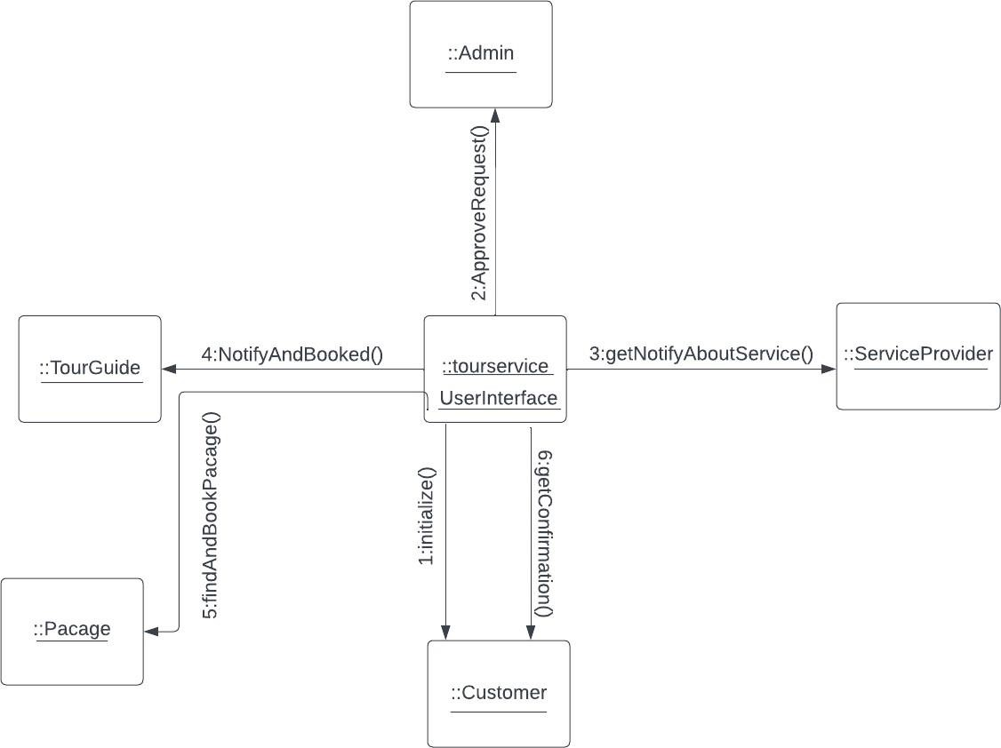

**21.3 Communication Diagram for “Translate”**

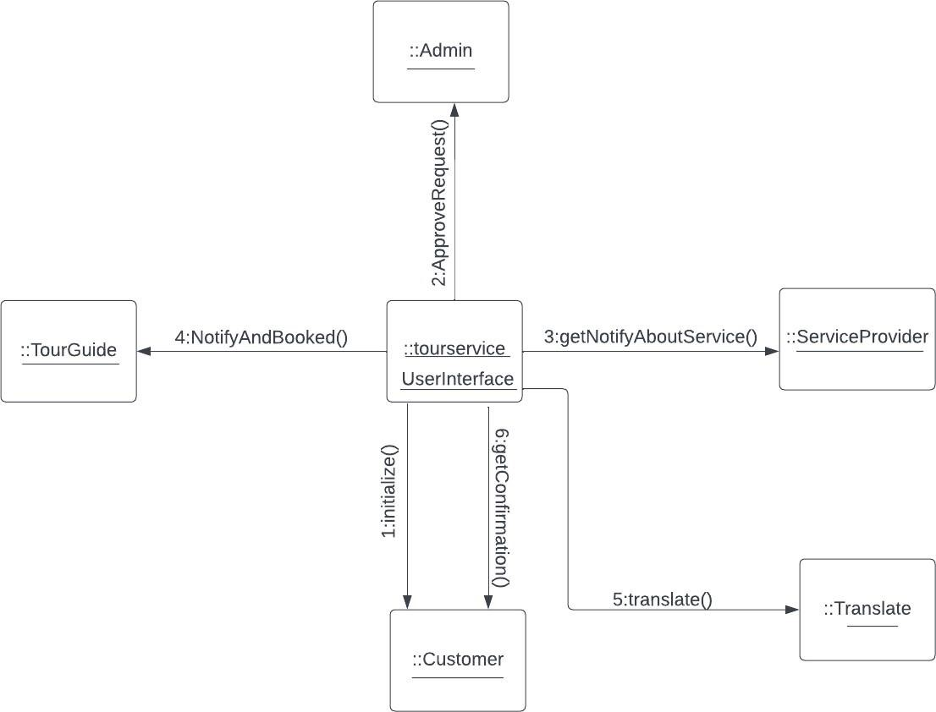

1. **Class diagram**

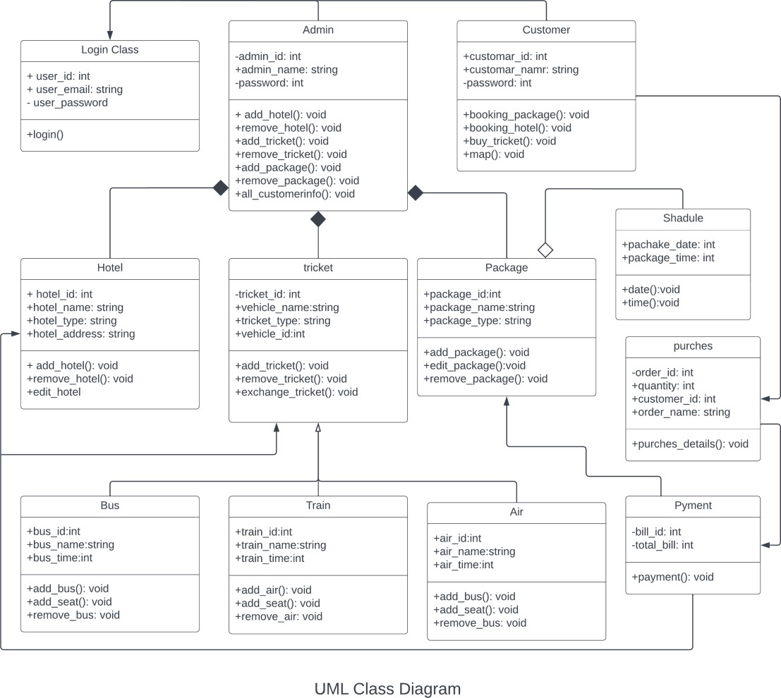

1. **State-chart diagrams for whole system**

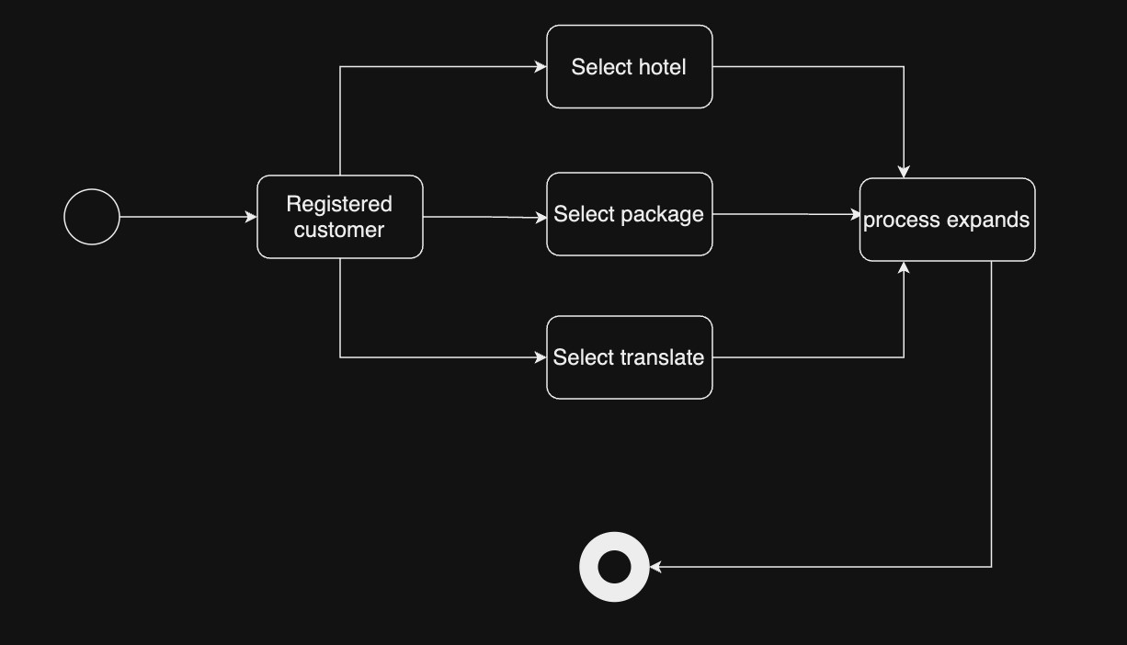

**23.2. State-chart diagram for “Hotel Booking”**

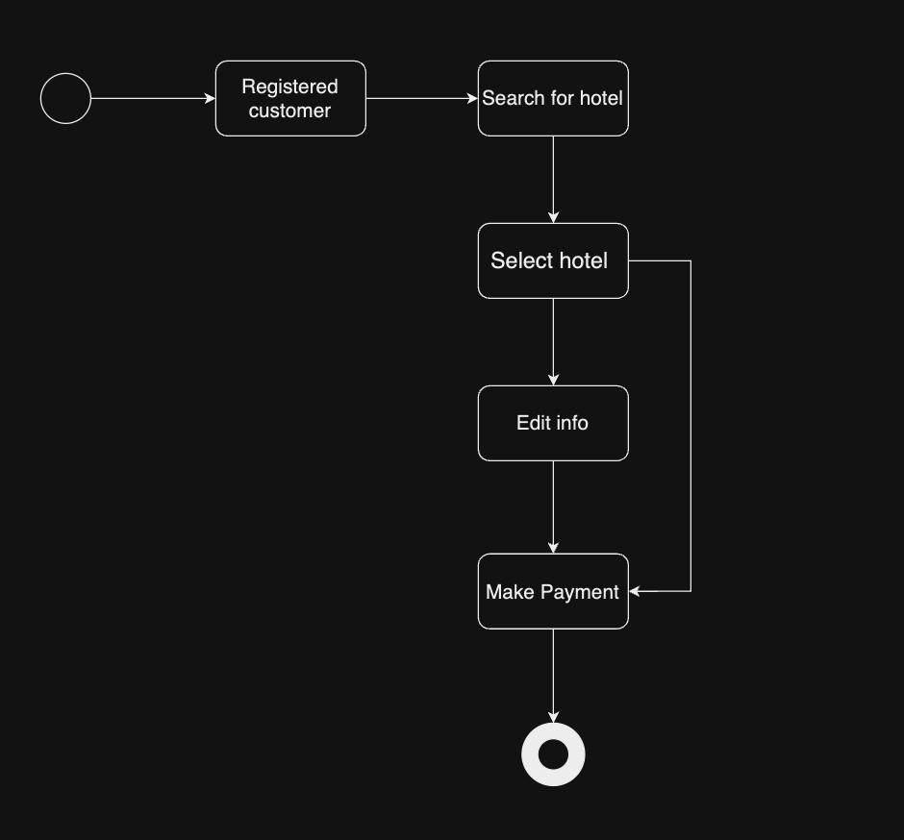

## 23.3. State-chart diagram for “Packages”

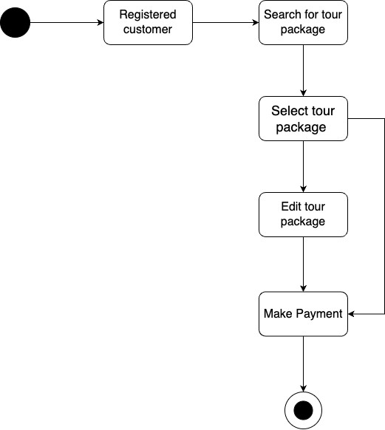

**23.4. State-chart diagram for “Translation”**

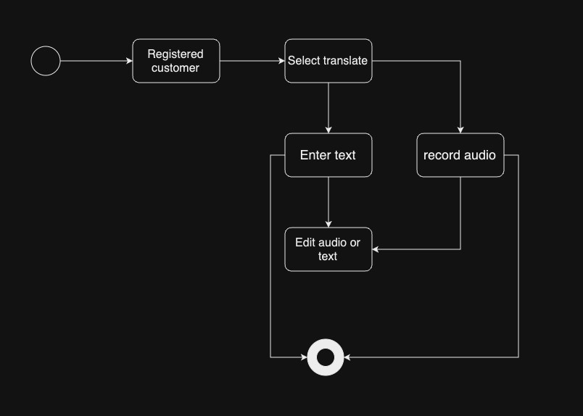

1. **CRUD Matrix**

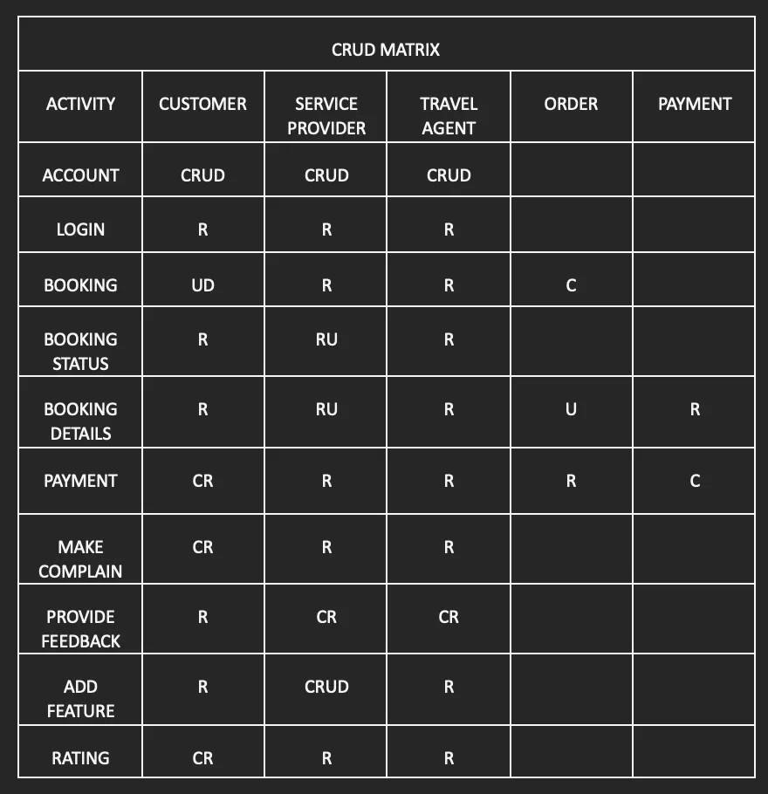

**Section 5:**

1. **Prototype the user interface**

* 1. **User Interface for Tourist**

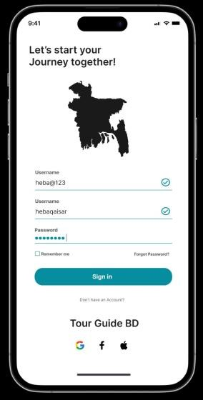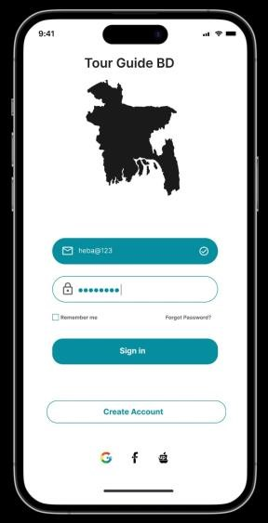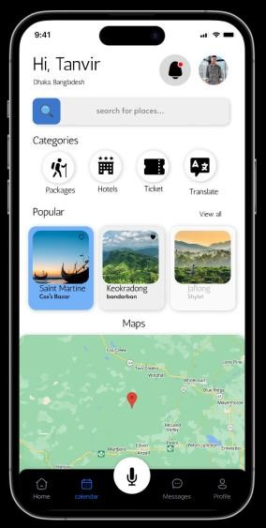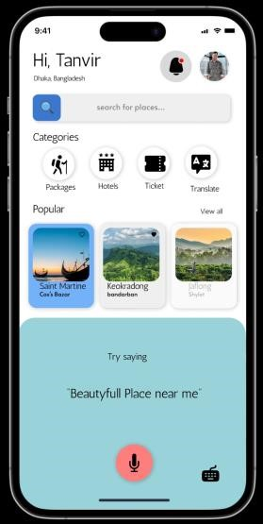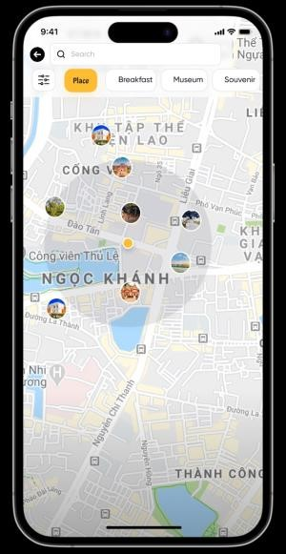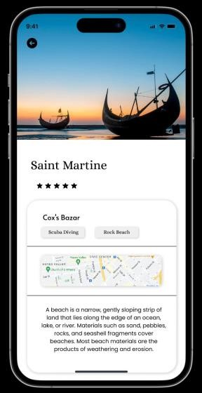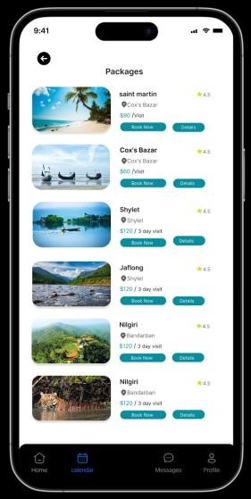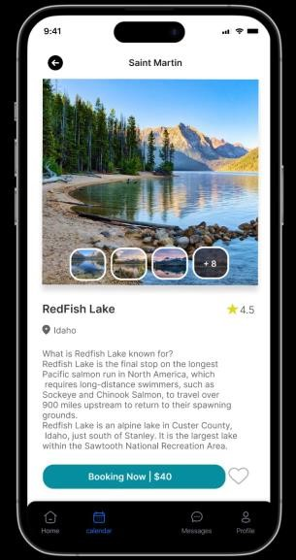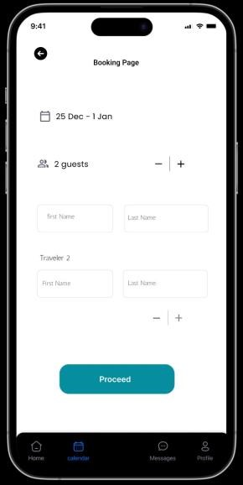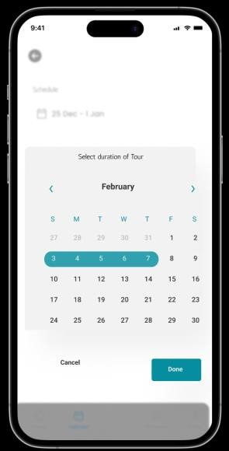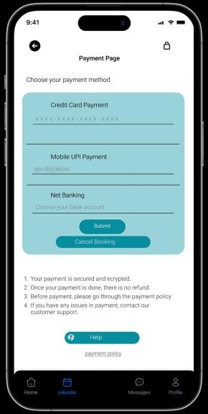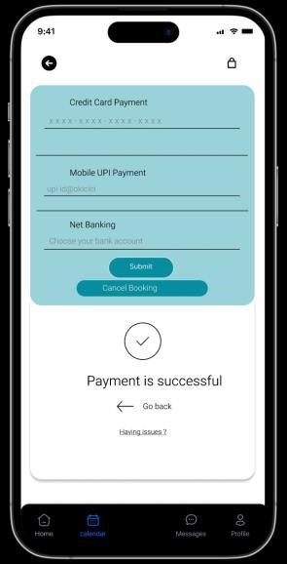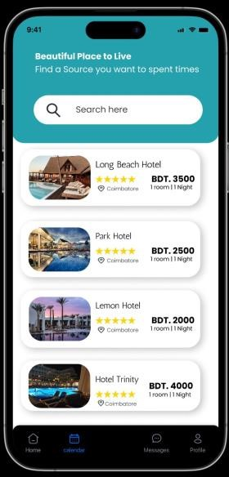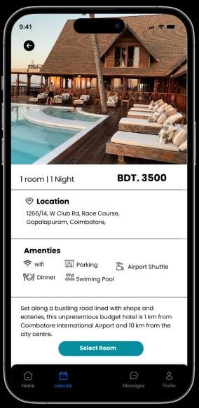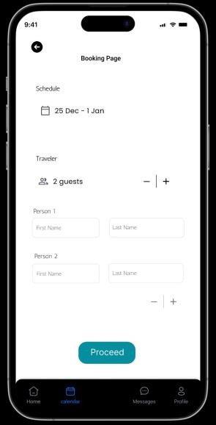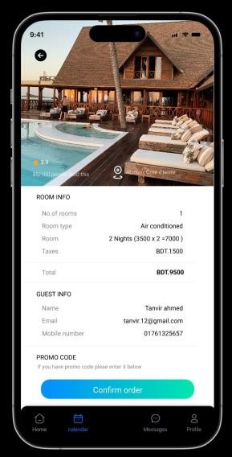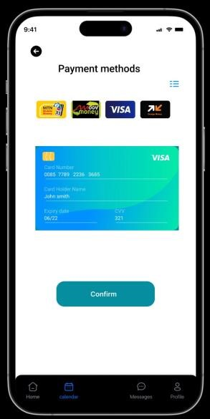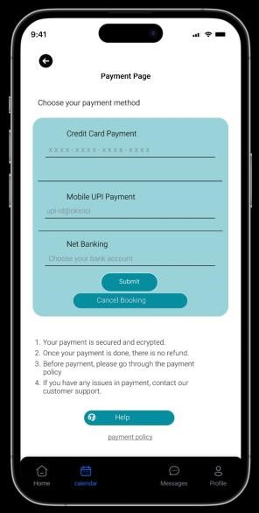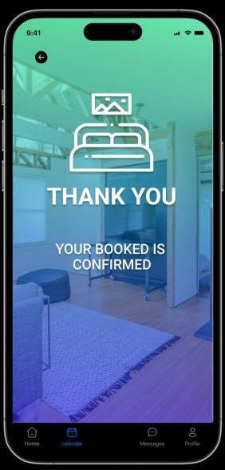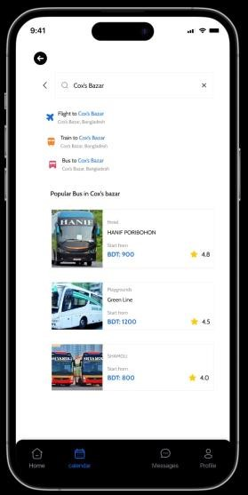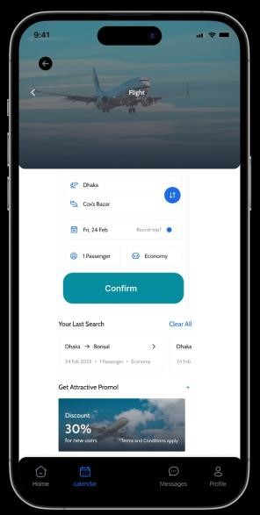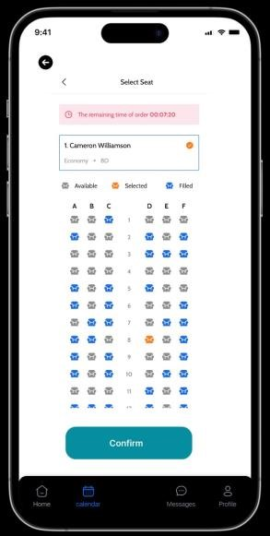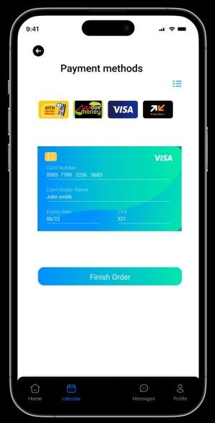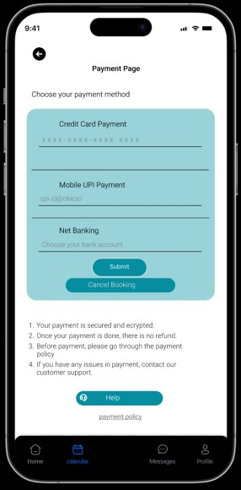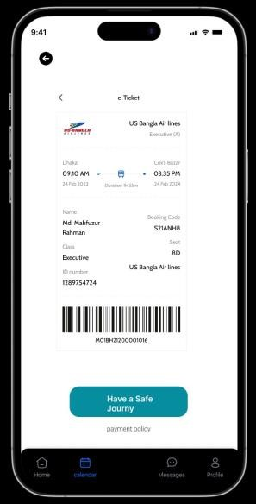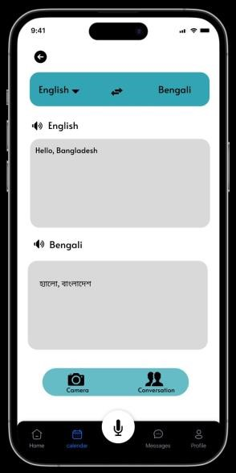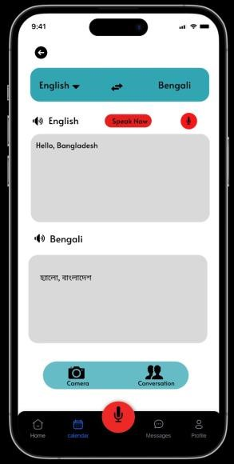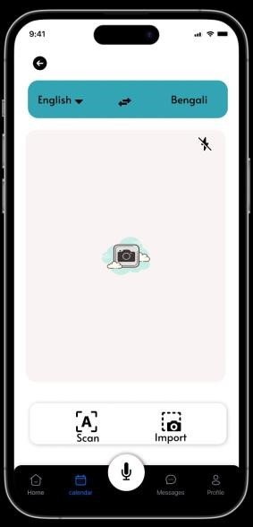

* 1. **User Interface for Admin**

